Predicting ATP tennis Match Winner
Topic and Motivation
Tennis offers a great opportunity to work on a predictive analysis as there is rich extensive match and player data to predict winners. It is outside so can be combined with weather data.
Data Description
The dataset combines match-level ATP data from the Jeff Sackmann Tennis Data Repository with weather data from NASA POWER Project.
- Match data includes player rankings and stats, match outcomes, tournament names, and locations.
- Weather data includes daily measures such as:
  - Maximum temperature (T2M_MAX)
  - Wind speed (WS2M)
  - Precipitation (PRECTOTCORR)
  - Humidity (RH2M)
Tournament locations were geocoded and matched to weather observations using latitude and longitude.
Data Processing
Several steps were taken to construct the final dataset:
- Merging datasets:
Weather data was accessed through the NASA Api and chosen based on date and location.
Match data were merged with weather data by tournament location and date.
Ranking features and data were merged on nearest prior date and player names. Nearest prior date was essential as I do not want to provide information on who won accidentally.
- Cleaning and validation
We restricted tournaments to 2010+ to ensure we used the highest quality data years with the least missing data and most player statistics. Dates where converted to the class-type dates to allow for nearest prior date. Other variables had to be classes properly as well.
Implausible weather values were removed, including:
  - Temperature inconsistencies (maximum less than minimum)
  - Negative precipitation or wind values
  - Humidity outside 0 to 100 percent
- Variable construction
  - Upset indicator: whether the lower-ranked player won
  - Ranking difference: difference between player and opponent rankings
  - Ranking rolling averages: current rank might not reflect player ability perfectly if an upset occurred.
  - Rank time diff: to get at rank momentum changes, 4wk, 8wk changes.
  - Extreme conditions: defined as the top 10 percent of each weather variable
  - Close matches: defined as ranking difference ≤ 20
- Design choices
NASA weather data were used instead of station-level NOAA data to ensure consistent global coverage and avoid missing observations. Originally, I wanted to use NOAA data as it is station based and therefore might more accurately represent the match conditions. Issues identifying a station near enough to the match location that had historical weather data, were prominent and slow. The API key limited inquiries too much. Already note when you reproduce my code pulling NASA data can take around 5-10 minutes. This is a significant improvement from the NOAA pull which could take over 30 minutes. Furthermore, NOAA data was only able to be done for approximately 45% of all matches. Switching to NASA data had the benefit of 100% coverage at the expense of non-station-based weather data. Threshold-based definitions of extreme conditions were chosen to isolate extreme events while maintaining sufficient sample size. For My thresholds I use the top decile of weather events.
Why weather data? Tennis is outdoors and weather effects are certainly real from personal experience. However, it is not clear weather would effect players differently enough to alter match outcomes. In my decision to get weather data my thought process was as follows: Weather on its own will not predict a winner but it may interact with various game characteristics and player characteristics in meaningful ways that allow for better predictions. Examples include serving dominant players struggling more in wind. Players who like short matches struggle in extreme heat when playing a player who likes long matches. In my figures below I will try and explore some of these possibilities and the results well I will let you see.

Figures and Interpretation
Figure 1: Global Distribution of Tournament Locations

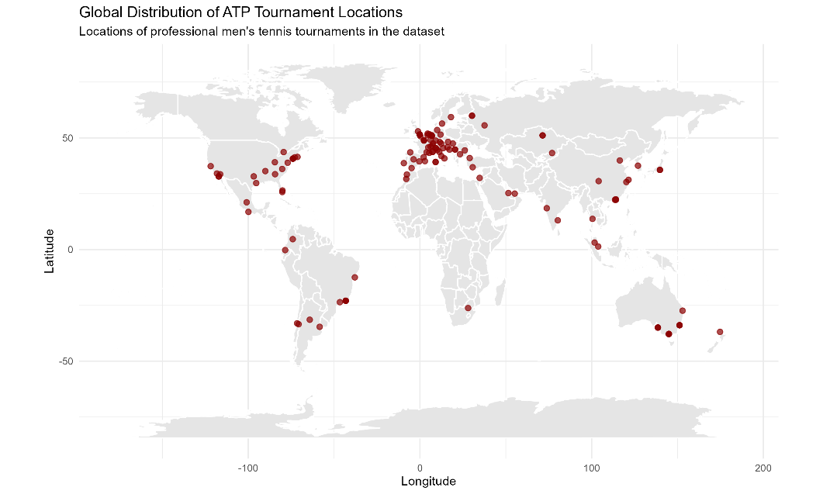
Purpose
To visualize the geographic coverage of the dataset and justify the use of globally consistent weather data.
Visualization choices
- A world map with point markers for tournament locations
- Minimal styling to emphasize spatial distribution
Interpretation
Tournaments are concentrated in Europe and North America, with additional clusters in Australia and East Asia. This uneven distribution reinforces the need for a globally consistent weather dataset.

Figure 2: Win Probability by Ranking Difference
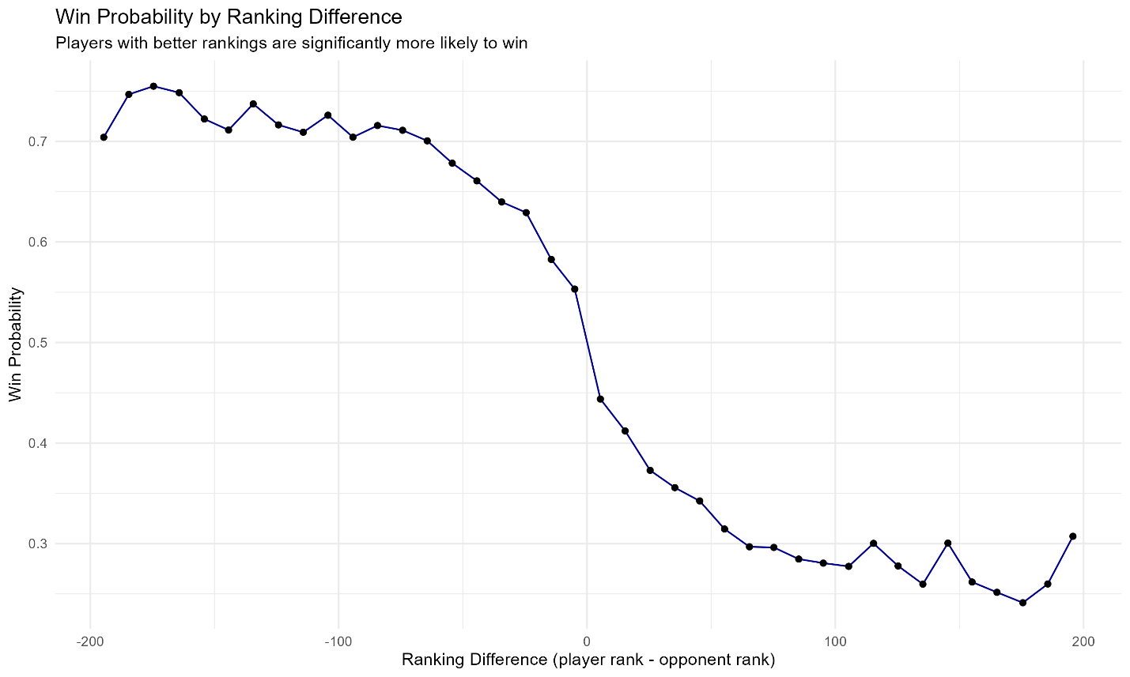
Purpose
To establish the baseline relationship between ranking difference and match outcomes.
Visualization choices
- Line plot to emphasize the continuous relationship
- Ranking difference centered around zero
Interpretation
Win probability decreases sharply as ranking disadvantage increases. This confirms that ranking is the dominant predictor of match outcomes and provides context for interpreting upset probabilities in later figures.

Figure 3: Weather Conditions and Upset Probability
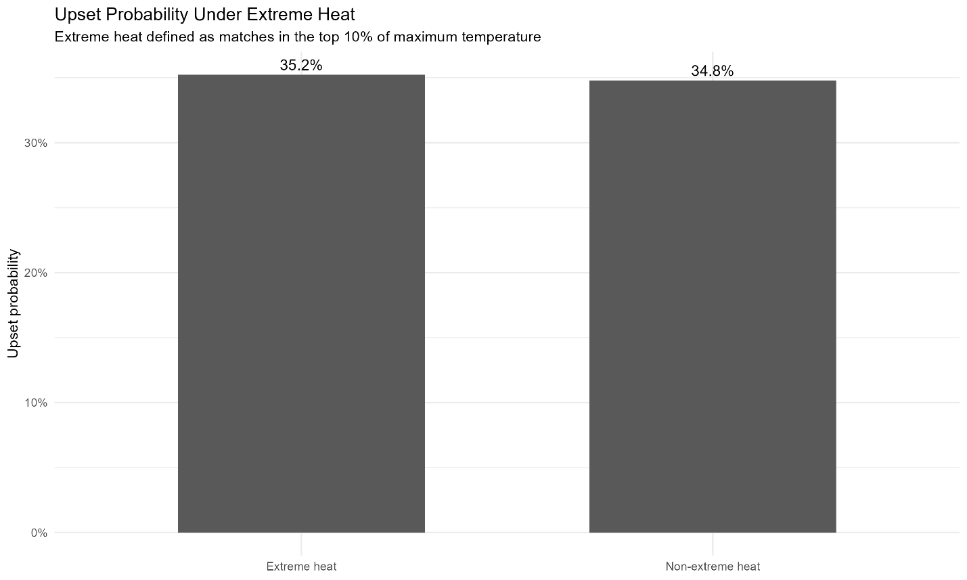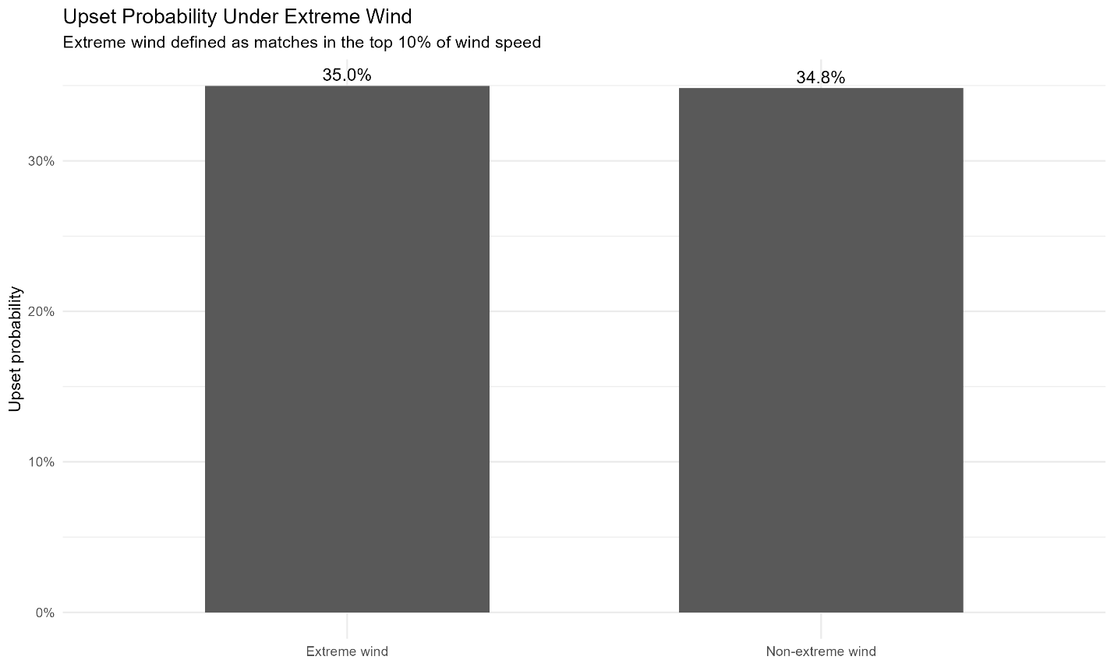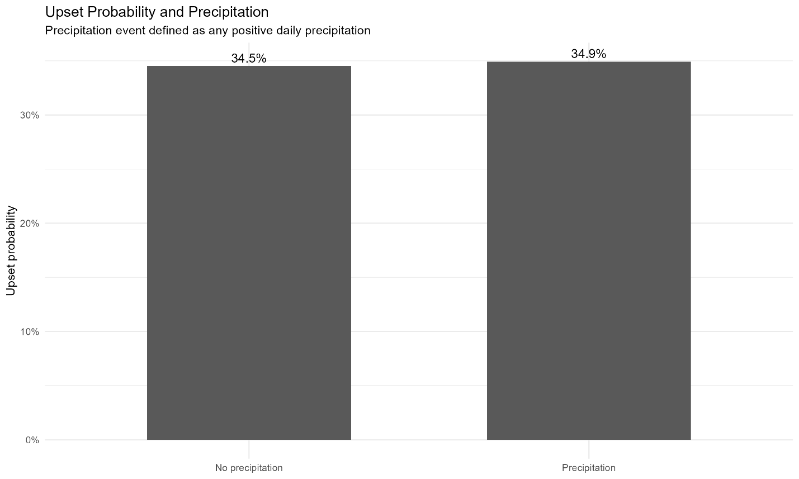
Purpose
To compare the effects of temperature, wind, and precipitation on upset probability.
Visualization choices
- Consistent two-bar format across all conditions
- Extreme conditions defined using top 10 percent thresholds
- Separate panels maintain clarity while allowing comparison
Interpretation
Across all three weather variables, differences in upset probability are small. This suggests that environmental conditions have limited impact on match outcomes relative to player skill.
Figure 4: Upset Probability by Ranking Difference

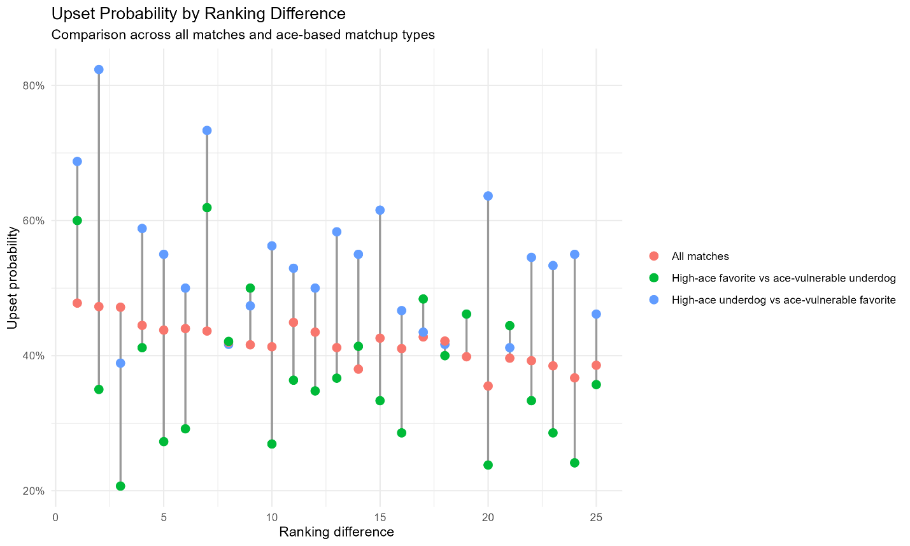

Purpose
To analyze how ranking differences interact with serve-related advantages in determining upset likelihood. This provides visual evidence of predictive features beyond player rank and highlights how known player characteristics can improve predictions.
Visualization choices
- Vertical dot groupings at each ranking difference
- Three color-coded groups:
  - All matches
  - High-ace favorite vs low-ace underdog
  - High-ace underdog vs ace-vulnerable favorite
- Vertical alignment emphasizes within-rank comparisons
Interpretation
Upset probability declines as ranking difference increases this is the general trend of our data also scene in figure 2. However, matchups involving serve advantages show meaningful deviations, indicating that play style can partially offset ranking differences. High Ace is defined as a player in the top quartile of first serve ace rates. Ace vulnerable is defined as a player in the top quartile of getting aced on serve returns. Favorite is defined as higher ranked player. Underdog is defined as lower ranked player.

